FINAL PROYECT
NAME: YAJAIRA PAGUAY
CLASS: 3RO “C” ACCOUTING
UNIT 1

MEET ALEX AND FRIENDS

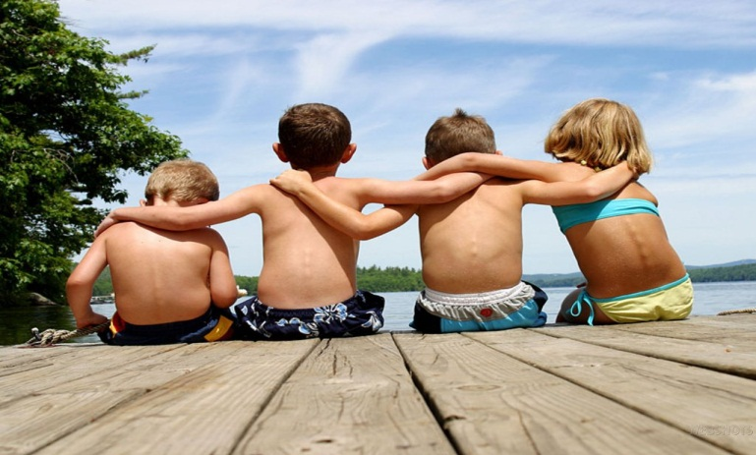

1. BOOKWORM: LECTOR
2. SHY: TIMIDO
3. PRETTY: BASTANTE (BONITA)

4. SMART: INTELIGENTE
5. NICKNAME: APODO
6. PERFORMING: EMPRENDEDOR
7. FRIENDLY: AMIGO

8. OUTGOING: EXTROVERTIDO
9. TRY: INTENTAR
10. CHALLENGING: RETO

SIMPLE PRESENT: TO

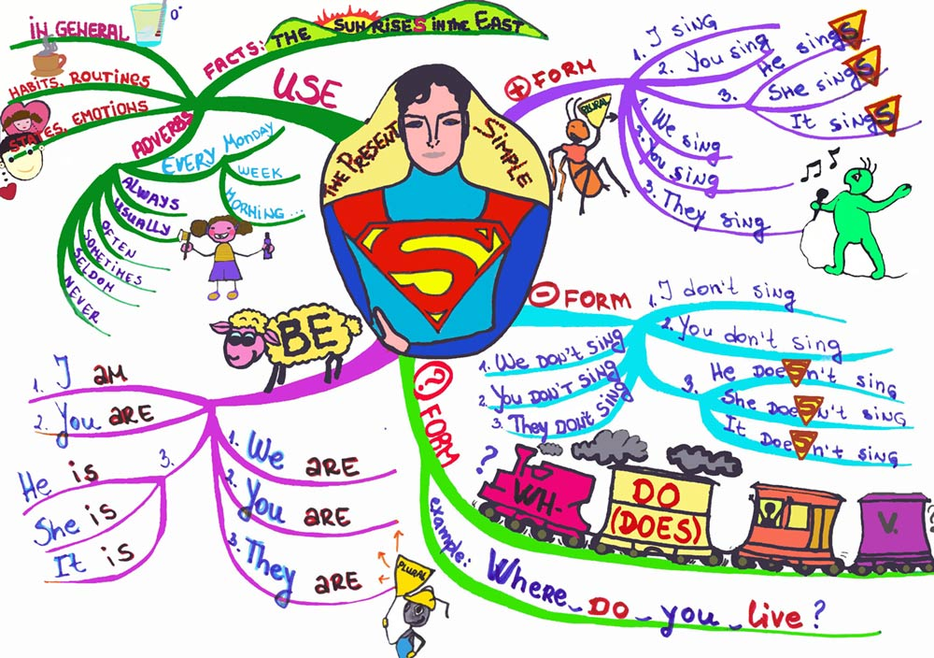

1.GREAT: GRANDIOSO
2.KEEP: GUARDAR

3. EXAETLY: EXACTAMENTE
4. BUSY: OCUPADO
5. THESE: ESAS
6. SOUNDS: SONIDOS
7. MIXTURE: MEZCLA
8. ENOUGTH: SUFICIENTE

UNIT 2

DO YOU HAVE ANY PIZZA DOUGH?

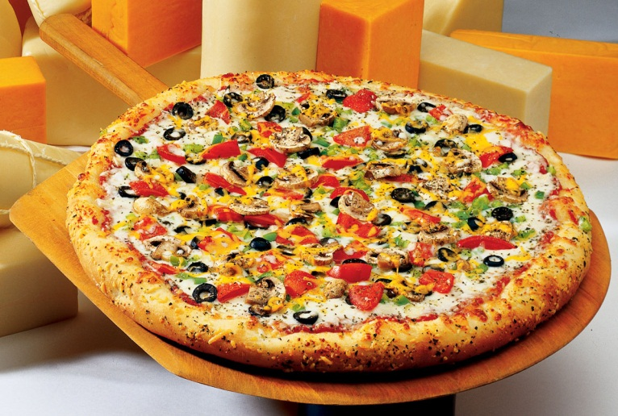

1. SPRINKLE: ROCIAR
2. PORK CHOP: CHULETA DE CERDO

3. HAM: JAMON
4. PEANUT: CACAHUATE
5. SEAFOOD: MARISCOS
6. JELLY: JALEA
7. PIE: EMPANADA
8. STEAK: FILETE
9. SHRIMP: CAMARON
10. GROSS: MAL SABOR
11. DOUGH: PASTA

12. OVEN: HORNO
13. SAUSAGES: SALCHICHAS
14. MAPLE SYRUP: JARABE DE ARCE

IMPERATIVE

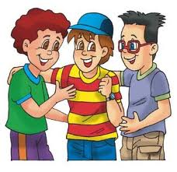

1. FRY: TOSTAR
2. TURN: VOLVER
3. TOAST: TOSTAR
4. SPRINKLE: ROCIAR

BECOMING A FAT NATION

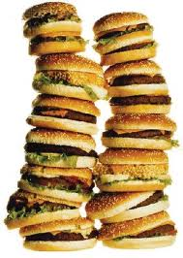
1. CANDY: CARAMELOS
2. HEART: CORAZON
3. DISEASE: ENFERMO

4. FAT: OBESO
5. OFFER: OFRECER
6. SAY: DECIR
7. ILLNESSES: ENFERMEEDADES
8. SURVERY: EXAMEN
9. WEIGHT: PESO
10. WAY: RUTA
11. CHOOSE: ESCOGER
12. FULL: COMPLETO

UNIT 3
ARE THERE ANY CHIPS LEFT?

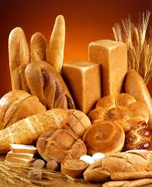

1. LOAF: PAN
2. SLOW: TARDO
3. COULD: SABER
4. POUND: LIBRA
5. JUNK: CHATARRA
6. DOWN: PLUMON

THAILAND’S FLOATING MARKETS

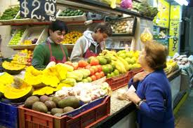

1. BOATS: BARCO
2. SHOP: TIENDA
3. FINE: ESTUPENDO

4. PEER: PAR
5. SAILING: PASEO EN BARCO
6. KIND: GENERO
7. WIFE: ESPOSA
8. FLOTING: FLOTANDO
9. OVERFLOWING: SOBREFLOTANDO
10. HUNDRESDS: CIENTO

UNIT 4
HOW OFTEN DOYOU GO ROCK CLIMBING?
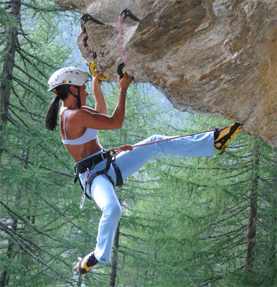

1. ALONG: A LO LARGO
2. LEAST: PEQUEÑO
3. RATHER: MEJOR
4. HATE: ODIAR
5. WALL: PARED –MURO
6. SEE: VEO ACOMPAÑAR
7. JOIN: JUNTAR
8. WEATHER: TEMPESTAD-TIEMPO
9. GUY: TIRANTE
10. SURE YOU DO: CIERTO-SEGURO
11. COUCH: LECHO
12. GUESS: CONJETURA

SPORTS AND ACTIVITIES
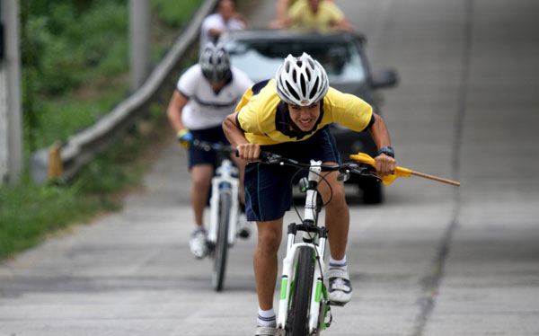
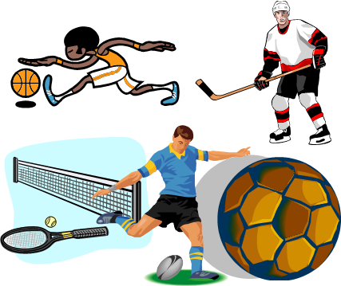

1. BIKING: CICLISMO
2. ROCK CLIMBING: ESCALAR EN ROCA
3. TRACK AND FIELD: DEPORTES DE ISTA
4. SKATEBOARDING: MONOPATIN
5. BASKETBALL: BASQUET
6. SWIMMING: NATACION
7. TABLE TENNIS: TENIS DE MESA

UNIT 5

EVERYBODY’S WAITING FOR US



1. RUN: COMPETIR
2. RIDE: MONTAR
3. GRACE: GRACIA
4. REQUIRE: REQUIERE
5. ARGUING: ARGUMENTO
6. TAKIN NOTAS: TOMANDO NOTAS
7. SLEEPING THE CLASS: DURMIENDO EN CLASES
8. GOSSIPY: CHISMOSO
9. SHOW: ENSEÑAR
10. WEAR: LLEVAR PUESTO
UNIT 6
WHAT ARE YOU GOING TO WEAR?
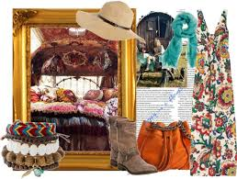

1. DRESS: VESTIDO
2. BELT: CITURON
3. T-SHIRT: CAMISETA
4. TOP: BLUSA
5. TIGHTS: AJUSTADO
6. PANTS: PANTALON
7. HONEST: HONRADO
8. TEENAGERS: ADOLESCENTES
9. SOCKS: CALCETINES
10. RINGS: ANILLOS
11. SHOES: ZAPATOS
12. JACKET: CHAQUETA

FINISH

